Library Genesis

What is LibGen
# Source: ScreenShots Source: Provided by: [Persons Table -> ID Column: 1, Name_En Column: Motasem Essam] -> Tool: [Lightshot Program] -> From [Site: https://welib.org/] on [9/21/2025]
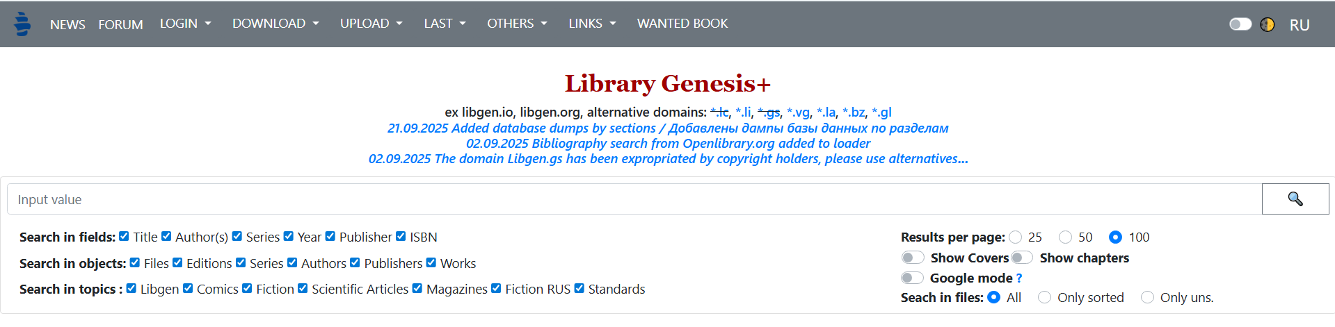
# Source: AI Source: Provided by: [Data Path: Persons Table -> ID Column: 1, Name_En Column: Motasem Essam] -> From: [ChatGPT] on [9/21/2025]
- Library Genesis (often “LibGen”) is a “shadow library” project that provides free access to a massive quantity of books, academic articles, comics, magazines, etc. (Wikipedia)
- It claims access to millions of items: scientific journal articles, academic & general-interest books, etc. (Wikipedia)
- It usually works by aggregating content it didn’t originally create — allowing users to search for links to files (“mirrors”) that might otherwise be paywalled or hard to find. (Wikipedia)

How LibGen Operates
# Source: AI Source: Provided by: [Data Path: Persons Table -> ID Column: 1, Name_En Column: Motasem Essam] -> From: [ChatGPT] on [9/21/2025]
- Multiple domain names / mirrors exist (because of legal pressure or blocks). Sometimes certain domains are down, but there are often alternatives. (Library Genesis Guide)
- Users can search by title, author, ISBN, etc., find a document/book, then download it from one of the mirrored links. (Wikipedia)

Legal & Ethical Issues
# Source: AI Source: Provided by: [Data Path: Persons Table -> ID Column: 1, Name_En Column: Motasem Essam] -> From: [ChatGPT] on [9/21/2025]
- Much of the content hosted or linked by LibGen is copyrighted — meaning it is not legally free to share in many jurisdictions. (Wikipedia)
- Because of this, using LibGen can be illegal or infringing intellectual property rights depending on local laws. (Wikipedia)
- There have been legal actions against LibGen in some places, and domain seizures or orders to block certain mirrors. (Wikipedia)

Risks for Users
# Source: AI Source: Provided by: [Data Path: Persons Table -> ID Column: 1, Name_En Column: Motasem Essam] -> From: [ChatGPT] on [9/21/2025]
- Legal risk: Depending on your country’s laws, downloading copyrighted material from LibGen could expose you to potential liability (though enforcement varies).
- Security risk: Files from unofficial or mirrored sources may not be safe. They could contain malware, or poor-quality scans, etc.

